DESIGN AND ANALYSIS OF ALGORITHMS
(23CSE211)

LAB-5

NAME: LOHITH BEJUGAM
R.NO: CH.SC.U4CSE24204
SEC: CSE-C
QUICK SORT
CODE:
#include <stdio.h>
#include <stdlib.h>

void swap(int *a, int *b)
{
int t = *a;
*a = *b;
*b = t;
}

int partition(int arr[], int low, int high)
{
int pivot = arr[high];
int i = low - 1;

for (int j = low; j < high; j++)
{
if (arr[j] <= pivot)
{
i++;
swap(&arr[i], &arr[j]);
}
}

swap(&arr[i + 1], &arr[high]);
return i + 1;
}

void quickSort(int arr[], int low, int high)
{
if (low < high)
{
int p = partition(arr, low, high);
quickSort(arr, low, p - 1);
quickSort(arr, p + 1, high);
}
}

int main()
{
int n;
scanf("%d", &n);

int *arr = (int *)malloc(n * sizeof(int));
if (arr == NULL) return 0;

for (int i = 0; i < n; i++)
scanf("%d", &arr[i]);

quickSort(arr, 0, n - 1);

for (int i = 0; i < n; i++)
printf("%d ", arr[i]);

free(arr);
return 0;
}
OUTPUT:
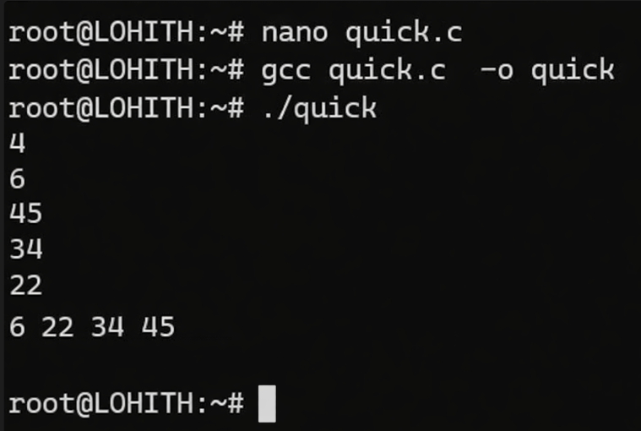

MERGE SORT:
CODE:
#include <stdio.h> #include <stdlib.h>
void merge(int a[], int l, int m, int r) { int i = l, j = m + 1, k = 0; int *temp = (int *)malloc((r - l + 1) * sizeof(int));
while (i <= m && j <= r)
{
if (a[i] <= a[j])
temp[k++] = a[i++];
else
temp[k++] = a[j++];
}
while (i <= m)
temp[k++] = a[i++];
while (j <= r)
temp[k++] = a[j++];
for (i = l, k = 0; i <= r; i++, k++)
a[i] = temp[k];
free(temp);
}
void mergeSort(int a[], int l, int r) {
if (l < r) {
int m = l + (r - l) / 2;
mergeSort(a, l, m);
mergeSort(a, m + 1, r);
merge(a, l, m, r);
} }
int main() {
int n; scanf("%d", &n);
int a[n];
for (int i = 0; i < n; i++)
scanf("%d", &a[i]);
mergeSort(a, 0, n - 1);
for (int i = 0; i < n; i++)
printf("%d ", a[i]);
return 0;}

OUTPUT:
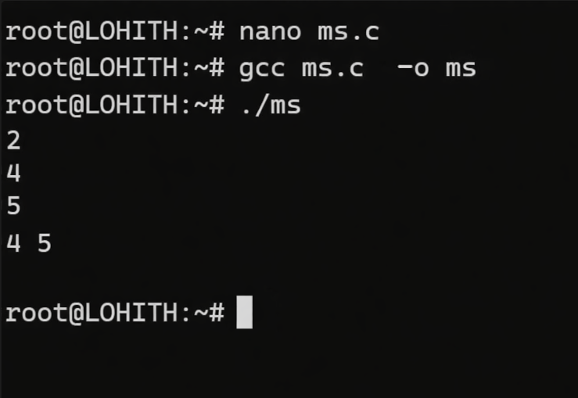

BST:
CODE:
#include <stdio.h>
#include <stdlib.h>
struct Node {
int data;
struct Node *left, *right;
};
struct Node* newNode(int data) {
struct Node* node = (struct Node*)malloc(sizeof(struct Node));
node->data = data;
node->left = node->right = NULL;
return node; }
struct Node* insert(struct Node* root, int data) { if (root == NULL) return newNode(data); if (data < root->data)
else if (data > root->data)
root->right = insert(root->right, data);
return root;}
void inorder(struct Node* root) {
if (root != NULL) {
inorder(root->left);
printf("%d ", root->data);
inorder(root->right); } }
int main() {
struct Node* root = NULL;
int n, x;
scanf("%d", &n);
for (int i = 0; i < n; i++)
{
scanf("%d", &x);
root = insert(root, x);
}
inorder(root);
return 0;
}
OUTPUT:
